A Project Report On

Coffee Shop

Submitted in partial fulfillment of the requirement for the award of the degree

Master of Computer Applications
(MCA)

Academic Year 2025 – 26

Viraj Jethva 92400584040
Harshit Varsani 92400584039
Yash Nageshree 92400584185

Internal Guide
Dr. Ashwin Dobariya



Rajkot-Morbi Road, At &PO :Gauridad, Rajkot 360 003. Gujarat. India.

Faculty of Computer Applications (FoCA)



This is to certify that the project work entitled

Coffee Shop

submitted in partial fulfillment of the requirement for

the award of the degree of
Master of Computer Applications (MCA)

of the

Marwadi University

is a result of the bonafide work carried out by

Viraj Jethva 92400584040

Harshit Varsani 92400584039

Yash Nageshree 92400584185

during the academic year 2025-26

Faculty Guide |  | HOD |  | Dean

DECLARATION

We hereby declare that this project work entitled Coffee Shop is a record done by us.

We also declare that the matter embodied in this project is genuine work done by us and has not been submitted whether to this University or to any other University / Institute for the fulfillment of the requirement of any course of study.

Place:
Date:

Viraj Jethva 92400584040 Signature: ___________
Harshit Varsani 92400584039 Signature: ___________
Yash Nageshree 92400584185 Signature: ___________

ACKNOWLEDGEMENT

It is indeed a great pleasure to express our thanks and gratitude to all those who helped us. No serious and lasting achievement or success one can ever achieve without the help of friendly guidance and co-operation of so many people involved in the work.

We are very thankful to our guide Dr. Ashwin Dobariya, the person who makes us to follow the right steps during our project work. We express our deep sense of gratitude to for his /her guidance, suggestions and expertise at every stage. A part from that his/her valuable and expertise suggestion during documentation of our report indeed help us a lot.

Thanks to our friend and colleague who have been a source of inspiration and motivation that helped to us during our project work.

We are heartily thankful to the Dean of our department Dr. R. Sridaran sir and HoD Dr. Sunil Bajeja sir for giving us an opportunity to work over this project and for their end-less and great support to all other people who directly or indirectly supported and help us to fulfil our task.

Viraj Jethva 92400584040 Signature: ___________
Harshit Varsani 92400584039 Signature: ___________
Yash Nageshree 92400584185 Signature: ___________

CONTENTS

Chapters | Particulars | Page No.
1 | Introduction to Project Definition | 8
2  2.1 | PREAMBLE  Module description | 9
3 | REVIEW OF LITERATURE  Analyze, Study and Compare the similar types of the systems/applications and highlights major findings | 10
4  4.1  4.2 | TECHNICAL DESCRIPTION  Hardware Requirement  Software Requirement | 11
5  5.1  5.2  5.3  5.4  5.5  5.6 | SYSTEM DESIGN AND DEVELOPMENT  - - Algorithm  - - Flow Chart  - - Data Flow Diagram  - - Class Diagram  - - Use Case Diagram  - - Sequential Diagram  - - Activity Diagram  - - State Diagram  - Database Design / File Structure (If applicable)  - Menu Design  - Screen Design  - Code of the module | 12
6 | SYSTEM TESTING | 37
7 | CONCLUSION | 39
8  8.1 | LEARNING DURING PROJECT WORK  Future Enhancement | 39
9  9.1  9.2 | BIBLIOGRAPHY  Online References  Offline References | 40

Table Index

Table No. | Title | Page No.
Table 4.1 | Hardware Requirement | 11
Table 4.2 | Software Requirement | 11
Table 5.9 | Database Tables | 23
Table 6.3 | Features to be Tested | 37
Table 6.4 | Functional Test Case | 38

Figure index

Figure No. | Title | Page No.
Figure 5.1 | System Architecture Diagram | 12
Figure 5.2 | Flow Chart | 14
Figure 5.3 | Data Flow Diagram | 16
Figure 5.4 | Class Diagram | 18
Figure 5.5 | Use Case Diagram | 19
Figure 5.6 | Sequential Diagram | 20
Figure 5.7 | Activity Diagram | 21
Figure 5.8 | State Diagram | 22
Figure 5.10 | Screen Design | 25

- Introduction to Project Definition

The Coffee Shop Application is designed to provide a digital platform for managing and ordering coffee in a simple, fast, and organized way. In today’s world, where time is valuable, people prefer easy solutions for daily needs such as food and beverages. Traditional methods of ordering in a coffee shop often take more time and may lead to mistakes in billing or serving. To solve these problems, this project introduces an application that makes the whole process easier for both customers and the shop.

This project focuses on creating an application where the menu of coffees is available in a structured manner. Users can see the different types of coffees, their prices, and details in one place. The system allows customers to select their choices, calculate the total price automatically, and move forward with the order in a smooth way. The design ensures that the entire process is user-friendly, accurate, and quick.

The main aim of this project is to improve efficiency in a coffee shop by reducing manual work, avoiding calculation errors, and saving time. Instead of handling everything with pen and paper, this digital approach ensures better management. It also improves the overall experience because customers can clearly see all available options and make decisions comfortably.

By using this system, the coffee shop becomes more organized and modernized, which is beneficial for both the business and the customers. It shows how technology can make even small daily activities, like buying a cup of coffee, more convenient and enjoyable.

- Preamble

Coffee shop operations require digital solutions for faster, more efficient, and error-free order processing. This mobile app simplifies customer interactions and empowers the administrator to manage product data in real-time, eliminating manual paper-based ordering and enhancing customer experience.

2.1 Module Description

User Side:
- Login with any username & Password
- Browse coffee items (cappuccino, mocha, flat white, etc.)
- Adjust quantity via plus/minus buttons
- View live total in cart
- Proceed to a payment page

Admin Side:
- Login with any username & Password
- Add new coffee items with name and price.
- Edit item prices or names.
- Delete old or wrong items.
- Changes reflect live in the user menu.

- REVIEW OF LITERATURE

Similar Systems Studied:
- Starbucks App: -
- Starbucks mobile app allows users to order drinks, customize them, and pay via the app.
- Menu is dynamic and managed by the admin side from the server.
Comparison: Your app has similar basic Starbucks ordering but on a local level using SQLite instead of cloud.

Conclusion from Review:
- Your Coffee Ordering App implements many important features from leading systems.
- While large apps are complex and online, your app is simpler, faster, and suitable for local cafes or college projects.
- It covers all basic functionality like menu display, cart, admin management, and payment simulation — all in one place.

- Technical Description

  - Hardware Requirement

Component | Specification
Android Device | Minimum Android Version: 5.1
 | Recommended RAM: 2 GB or more
 | Screen Size: 5 inches or more (for UI clarity)
Computer/Laptop | Minimum 4 GB RAM, i3 Processor
 | Disk Space: at least 2 GB free for project
USB Cable | To run the app on a physical Android device
Table 4.1 Hardware Configuration

  - Software Requirement

Software | Purpose
Android Studio | IDE to build the app using Java and XML
Java JDK 8 or above | Required to compile Java code
SQLite (built-in) | To store and manage menu items locally
Gradle | Build tool used by Android Studio
Android Emulator | To test the app without a real device
Table 4.1 Software Requirement

- System Design and Development

  - Algorithm

- User Module Algorithm

Step 1: Start the app, Display homepage with User Login and Admin Login buttons
Step 2: User clicks User Login
Step 3: Enter any username, Password Click “Login”
Step 4: Open menu screen
Step 5: Load items from SQLite database
Step 6: For each item in menu:
Show name, price, and quantity counter
User clicks + button – increase quantity
User clicks – button – decrease quantity (if > 0)
Step 7: On "Go to Cart" click:
Display only selected items
Calculate total price = sum of (item price × quantity)
Step 8: User selects Cash or UPI (optional future scope)
Step 9: Click on Confirm Payment – Display “Payment Successful” toast/message
Step 10: End

- Admin Module Algorithm

Step 1: Admin clicks Admin Login
Step 2: Enter fixed credentials: username, Password Click “Login”
Step 3: If login valid - go to Admin Panel
Step 4: Admin can perform:
Add Item - insert into SQLite table
Update Item - update name/price in SQLite
Delete Item - remove item from SQLite
All items are shown in ListView with click-to-edit support
Step 5: End

Flowchart: -

Admin Flowchart

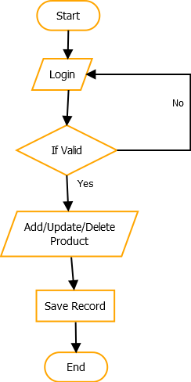
Figure 5.2 Admin Flow Chart

User Flowchart

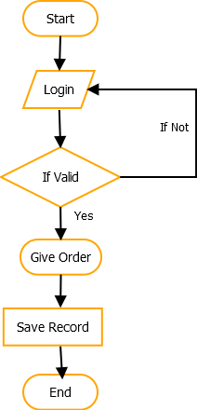
Figure 5.3 Admin Flow Chart

Data Flow Diagram
(Zero Level)

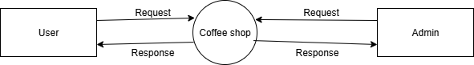

Figure 5.4 Data Flow Diagram (Level 0)

Data Flow Diagram
(First Level)

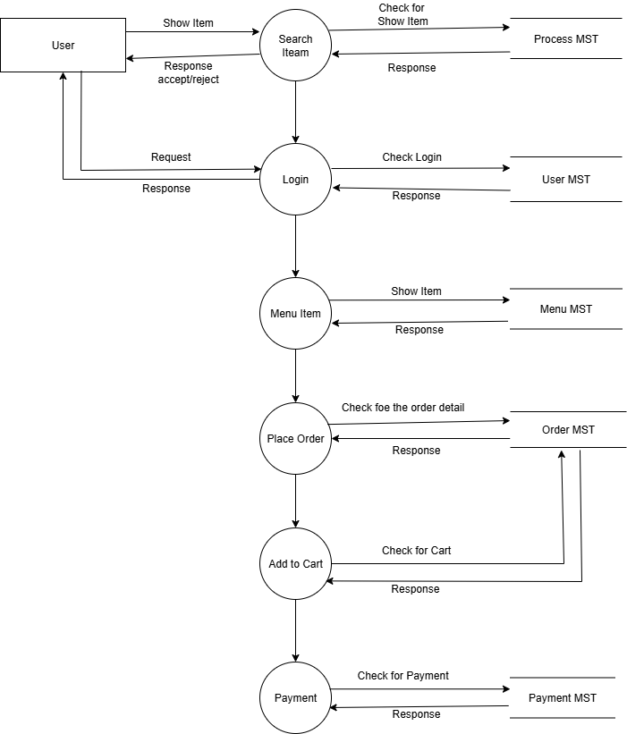

Figure 5.5 Data Flow Diagram (Level 1)

Class Diagram: -

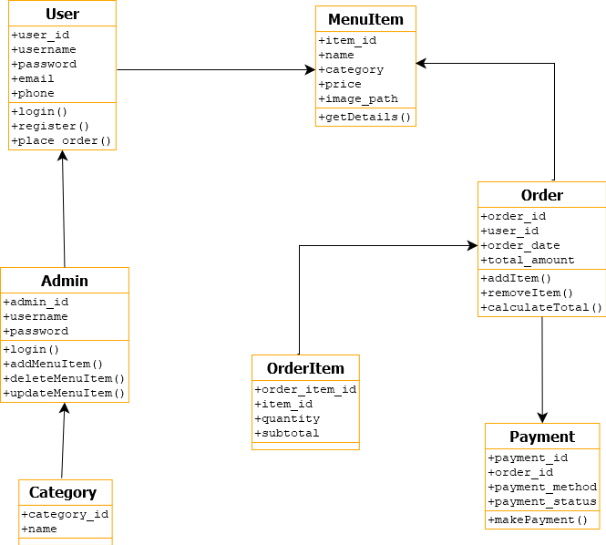

Figure 5.6 Class Diagram

Use Case Diagram: -

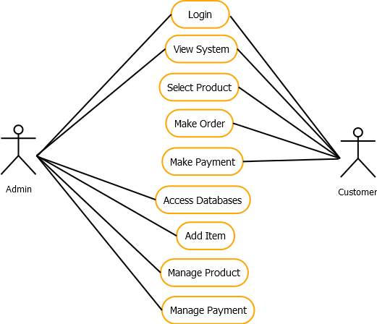

Figure 5.7 Use Case Diagram

Sequential Diagram: -

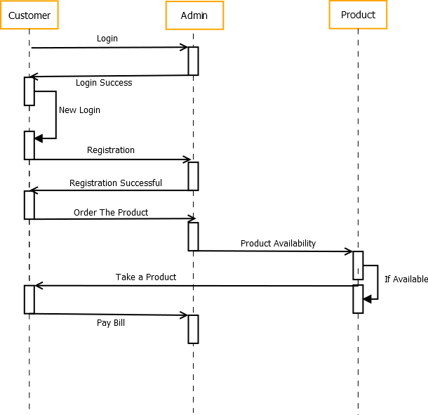

Figure 5.8 Sequential Diagram

Activity Diagram

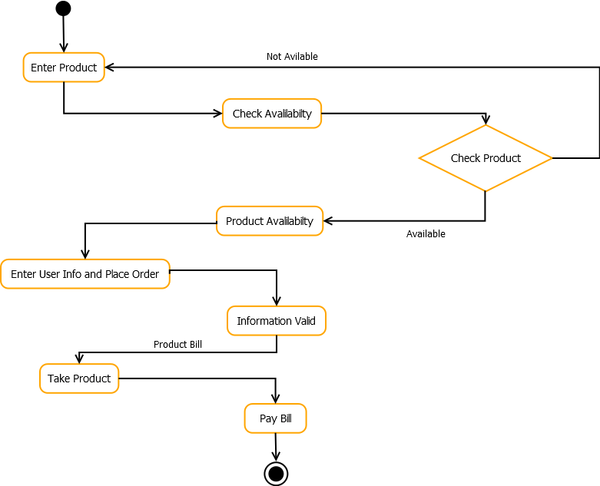

Figure 5.9 Activity Diagram

State Diagram: -

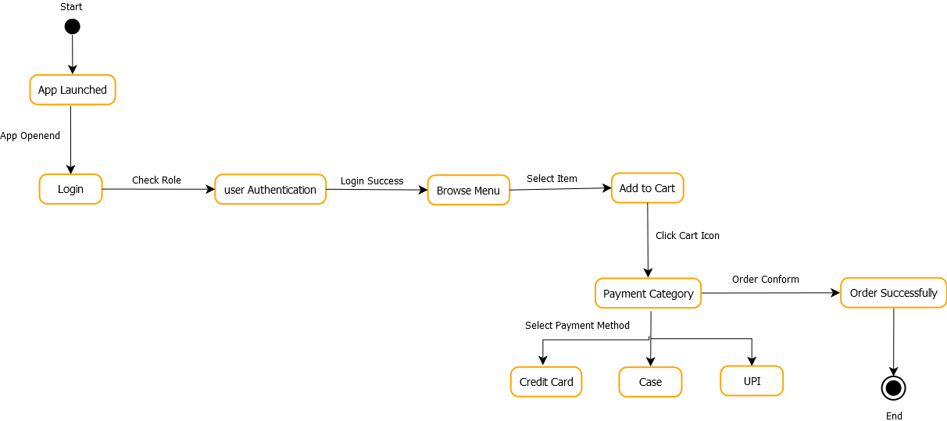

Figure 5.10 State Diagram

Database Table:

Table Name: users

Attribute Name | Datatype | Constraints
Id | Int | Primary Key
Name | Varchar (10) | -
Email | Varchar (10) | -
Password | Int | -
Table 5.11 Users Table Structure

Table Name: menu_item

Attribute Name | Datatype | Constraints
Id | Int | Primary Key
Category_id | Int | -
Name | Varchar (20) | -
Price | int | -
Table 5.12 Menu_Item Table Structure

Table Name: orders

Attribute Name | Datatype | Constraints
Id | Int | Primary Key
User_id | int | -
Item name | Varchar (100) | -
Quantity | Int | -
Table 5.13 Orders Table Structure
Table Name: category_table

Attribute Name | Datatype | Constraints
Id | Int | Primary Key
Name | Varchar (20) | -

Table 5.14 Category_Table Structure

Table Name: order_status

Attribute Name | Datatype | Constraints
Id | int | Primary Key
User_id | int | -
total | int | -
status | Varchar (10) | -
Table 5.15 Order_Status Table Structure

Table Name: admin
Attribute Name | Datatype | Constraints
Id | Int | Primary Key
Username | Varchar (50) | -
Password | Varchar (50) | -

Table 5.16 Admin Table Structure

Screen Design: -
User Login: -

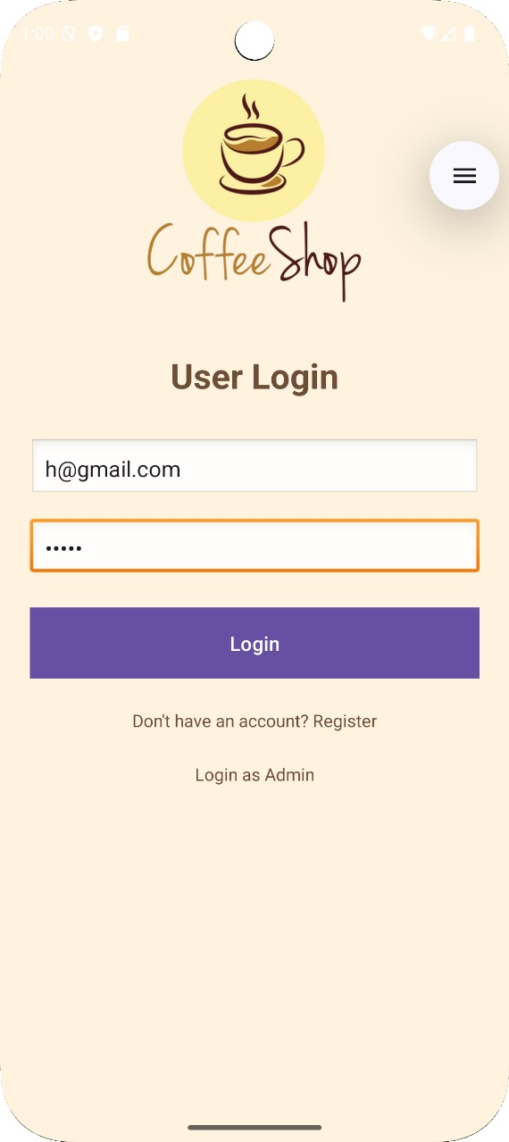
Figure 5.17 User Login Screen

In this page we will display the user login with Email and Password to login the app of the Coffee Shop
Splash Screen: -
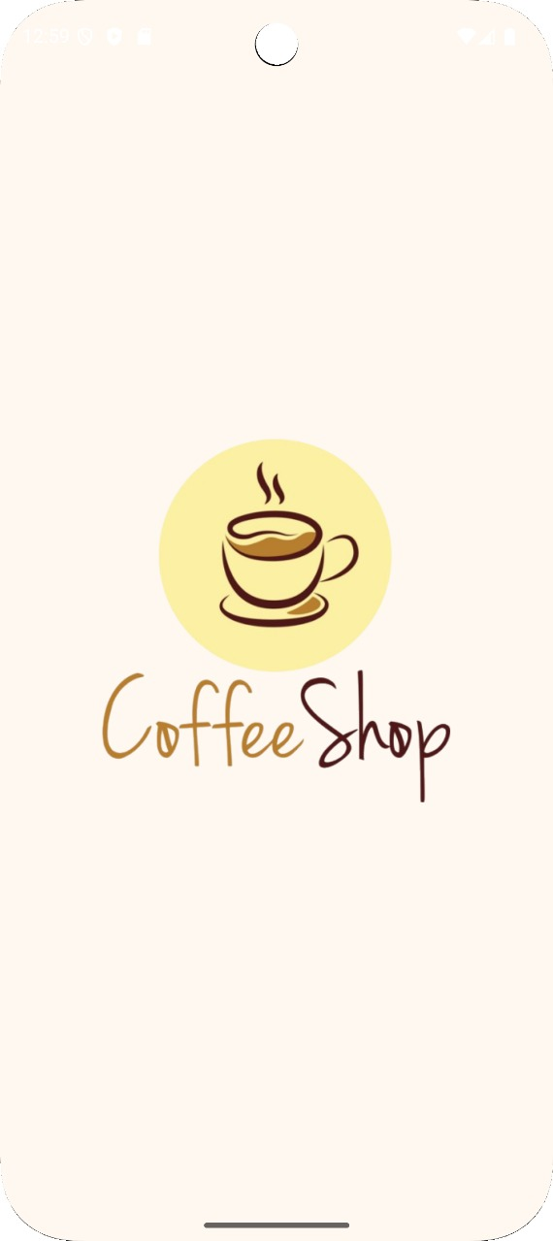
Figure 5.18 Splash Screen

In this screen we will display the splash activity of the after the login is done the logo will display for 3 seconds and menu will display after that
User Registration: -

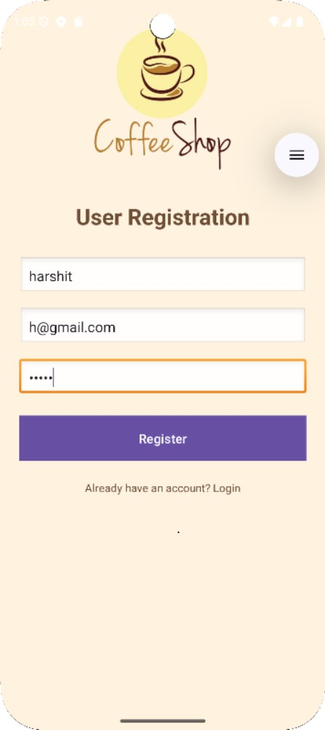
Figure 5.19 User Registration Screen

In this screen we will display the user registration with name, email, password is showing. User will register in the app
Menu Item: -

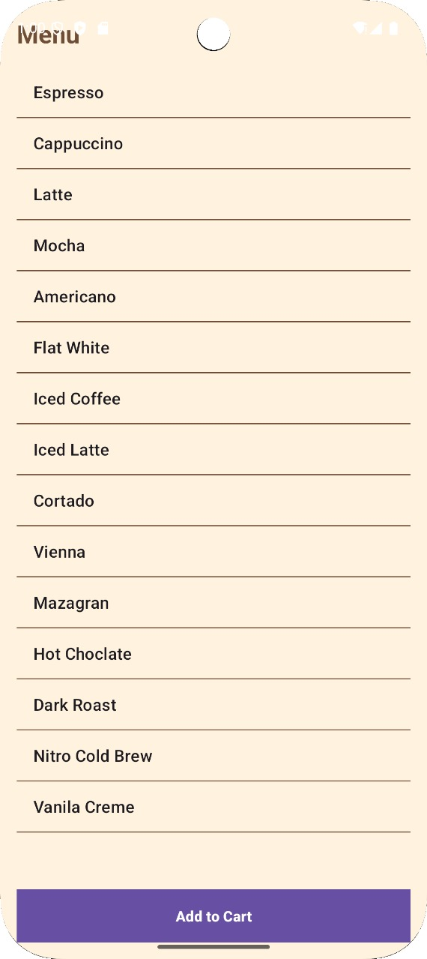
Figure 5.20 Menu Screen

In this screen we will display the all-coffee menu items with scrollable view form

Item Detail: -

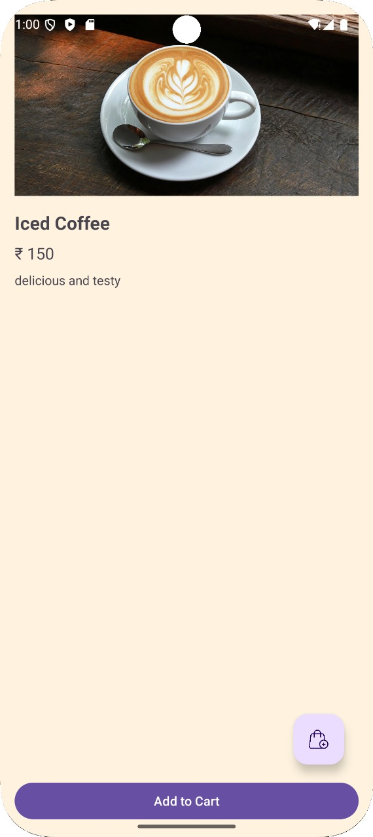
Figure 5.21 Item Detail Screen

In this screen we display the menu items are showing in the screen with their price and quantity

Your Cart: -

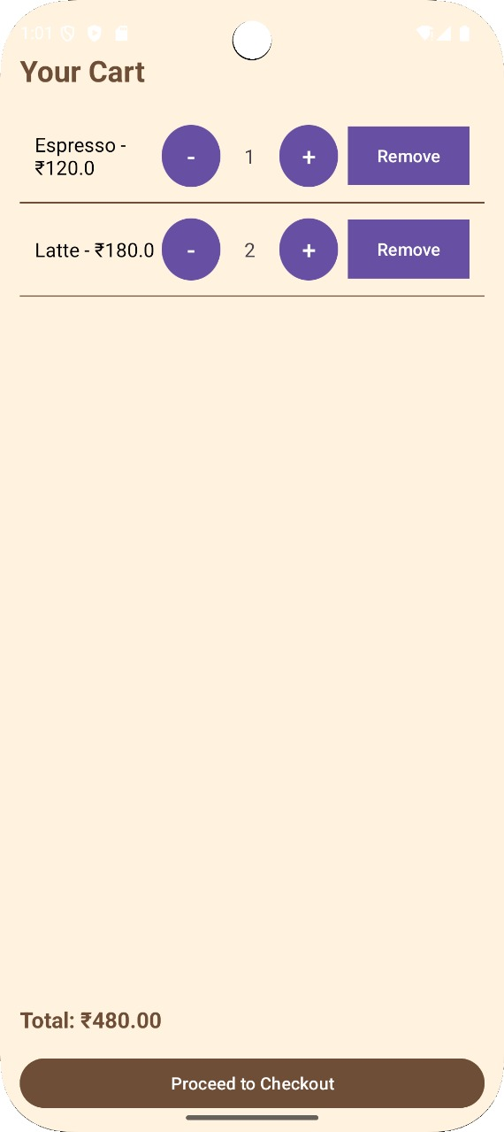
Figure 5.22 Cart Screen

In this screen we will showing the add items with their price and quantity
Check Out menu: -

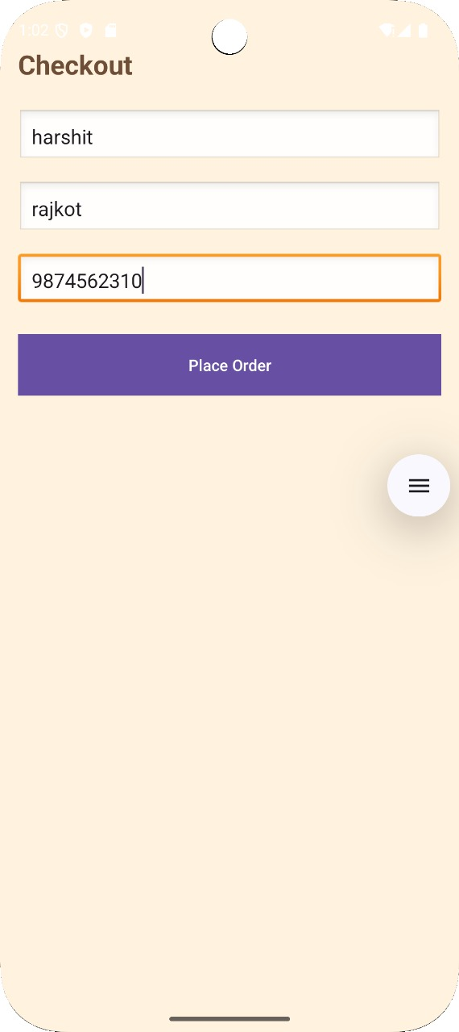
Figure 5.23 Checkout Screen

In this screen we will showing the display user detail like name, address, phone number and conform click on place order button

Make a Payment: -
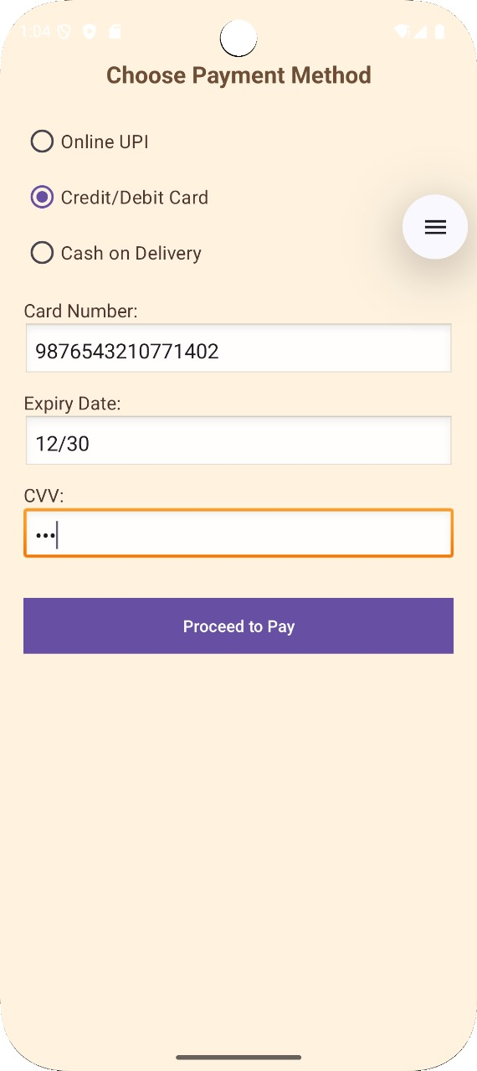
Figure 5.24 Payment Screen

In this screen we will display the payment categories and choose any one and click on processed to pay button on it

Order Conformation: -

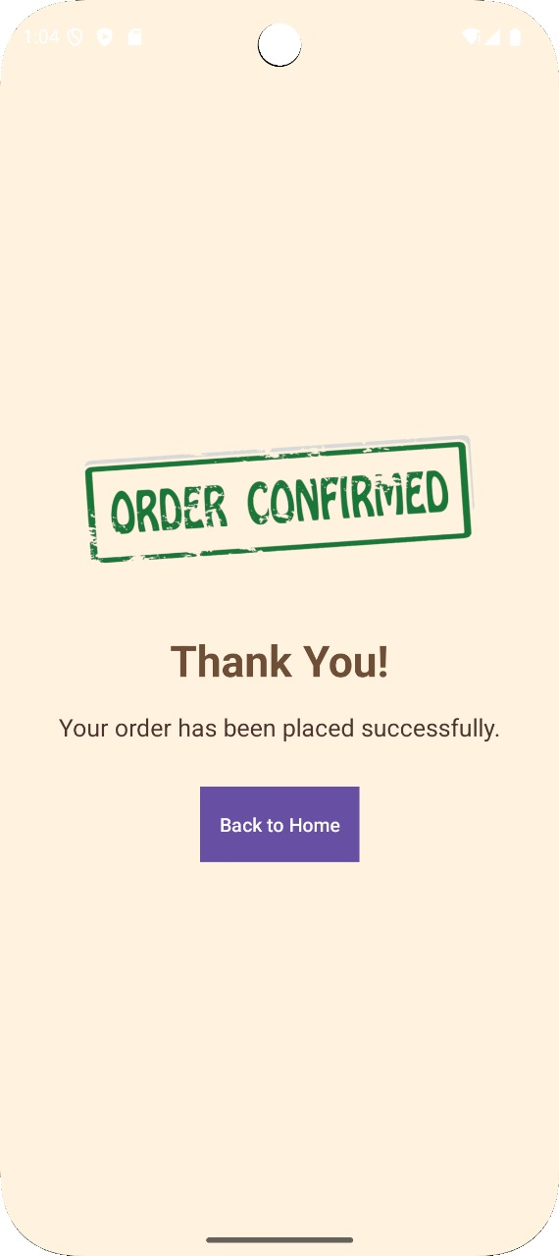
Figure 5.25 Order Confirmation Screen

This is the final page of the app will show the order will place successfully and order conformed will display and click back to home again

Admin login: -

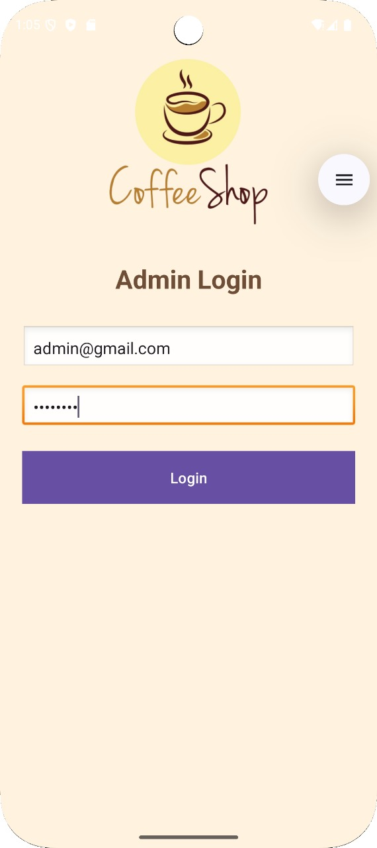
Figure 5.26 Admin Login Screen

In this we will display the admin login page with their email, and password and click on login button
Admin Dashboard: -

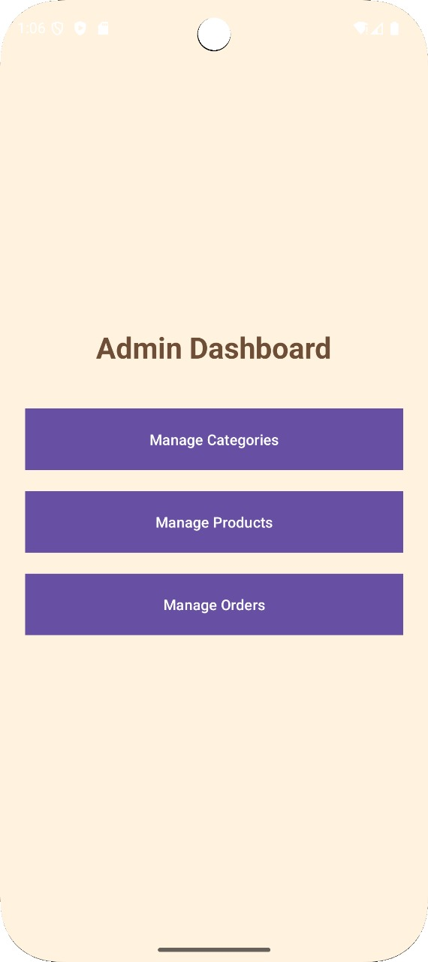
Figure 5.27 Admin Dashboard Screen

In this screen we will display admin dashboard categories to manage the things like add, update and delete and manage menu list

Add item Page: -

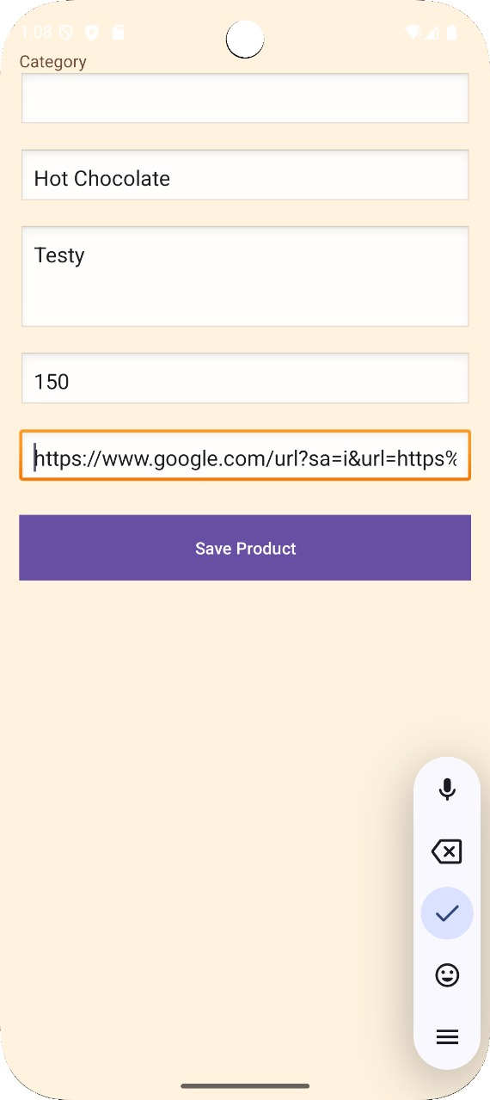
Figure 5.28 Add Item Page Screen

In this page we will show the product name, price, category etc. to update the things in menu and click on save button

- System Testing:
6.1 Objective:
System testing ensures that the Coffee Shop Application (with menu, add-to-cart, order, etc.) works as a complete and integrated system according to requirements.

6.2 Scope:
The testing will cover:
- Functional Testing – Verifying all features (menu display, add/remove items, order confirmation, payment).
- UI Testing – Buttons, layouts, navigation flow.
- Performance Testing – App response with multiple items/orders.
- Compatibility Testing – Runs on different Android versions/devices.
- Error Handling – Invalid inputs, missing selections.

6.3 Features to be Tested:
Feature | Description | Expected Result
App Launch | Open Coffee Shop app | Splash screen → Homepage
Menu Display | Show coffee items with price | All items visible
Add Item (+) | Add coffee item to cart | Item count increases
Remove Item (-) | Remove item from cart | Item count decreases
Cart Summary | Shows selected items & total | Correct total displayed
Place Order | User confirms order | payment screen
Error Handling | Try order with empty cart | Show error message
Exit App | User closes app | App exits gracefully
Table 6.3 Features to be Tested
6.4 Test Cases:
Functional Test Cases

Test Case ID | Test Case Description | Test Steps | Input Data | Expected Result | Actual Result | Pass/Fail
TC-01 | Verify app launch | 1. Open app | N/A | Splash screen → Homepage | Homepage displayed correctly | Pass
TC-02 | Add item to cart | 1. Select Cappuccino  2. Click (+) | Cappuccino | Item added to cart, qty=1 | Item added, qty=1 | Pass
TC-03 | Remove item from cart | 1. Add Cappuccino  2. Click (–) | Cappuccino | Qty decreases / item removed | Item not removed, qty stays same | Fail
TC-04 | Add multiple items | 1. Add Latte  2. Add Espresso  3. Add Mocha | Latte, Espresso, Mocha | All items visible in cart | Only Latte and Espresso visible (Mocha missing) | Fail
TC-05 | Empty cart order | 1. Open cart  2. Click Place Order | No items | Error message “Cart Empty” | App crashes unexpectedly | Fail
TC-06 | Place order with items | 1. Add Cappuccino (₹200), Latte (₹180)  2. Click Place Order | 2 items | Bill screen displayed with total ₹380 | Bill screen displayed with wrong total ₹360 | Fail
TC-07 | Exit app  gracefully | 1.Press back button  twice | N/A | App exits  Without crash | App exited  properly | Pass
Table 6.4 Functional Test Cases
6.5 Tools for Testing:
- Android Studio Emulator
- Physical Device Testing

6.6 Exit Criteria:
- All critical test cases passed (Add/Remove items, Place Order,)
- UI works across multiple devices.
- Conclusion:

This Coffee Shop app project allows users to browse different coffee items, add them to a cart, and make orders easily. It demonstrates basic app functionalities like user login, admin login, database connection, item management, and a smooth user interface. Overall, the project shows how an online ordering system works in a small business, providing convenience to customers and helping shop owners manage orders efficiently.

- Learning During Project Work:

- Learned how to design a user-friendly app interface.
- Gained knowledge of Java and XML for Android development.
- Understood how to connect an app with a database (MySQL).
- Learned to implement features like login, cart, and payment.
- Improved problem-solving and debugging skills.

8.1) Future Enhancement:

- Add online payment integration (like PayPal or UPI).
- Include more coffee varieties and offers.
- Enable order tracking in real-time.
- Add user feedback and rating system.
- Make the app available on multiple platforms (iOS, Web).

- Bibliography:

9.1) Online References:

[1] Tutorials Point, “Android SQLite Database Tutorial.” [Online]. Available: https://www.tutorialspoint.com/android/android_sqlite_database.htm. [Accessed: Jun. 5, 2025].

[2] GeeksforGeeks, “SQLite in Android.” [Online]. Available: https://www.geeksforgeeks.org/sqlite-in-android/. [Accessed: July.16, 2025].

[3] MongoDB Inc., “What is MongoDB?” [Online]. Available: https://www.mongodb.com/docs/manual/introduction. [Accessed: July. 25, 2025].

9.2) Offline References:

[1] A. Silberschatz, H. F. Korth, and S. Sudarshan, Database System Concepts, 6th ed. New York, NY, USA: McGraw-Hill, 2019.
[2] R. Elmasri and S. B. Navathe, Fundamentals of Database Systems, 7th ed. Boston, MA, USA: Pearson, 2016.
[3] H. Schildt, Java: The Complete Reference, 11th ed. New Delhi, India: McGraw-Hill, 2019.

